St. Norbert College

Financial Procedures Guide
(2024)

CONTENTS

CONTENTS 2
THE BIG FINANCIAL PICTURE 4
Introduction 4
Administrative Software System Overview 5
Fiscal Year 6
Accrual Basis of Accounting 6
Types of Accounts 6
Financial Statements 7
Statement of Financial Position (Balance Sheet) 7
Statement of Activities (Income Statement) 7
Statement of Cash Flows 7
COLLEGE ADMINISTRATIVE SYSTEMS 8
Access to Financial Information 8
Workday Financials Security Model 8
Workday Finance Role Assignment Change Process 10
Workday Adaptive Planning Security Model 10
Visibility to Salary Data in Adaptive Planning 12
Visibility to Aggregated Personnel Costs in Adaptive Planning 12
Access to Workday Adaptive Planning 12
Workday Foundation Data Model - FDM 13
Workday Custom Validations 14
Basic Workday Financial Reports 14
Adaptive Planning 17
COLLEGE ACCOUNTING MANAGEMENT 18
Requesting Transfers, Adjustments and Corrections 19
Understanding and Managing Agency Funds 19
Understanding Endowments 19
Endowment Asset Pooling 20
Endowment Spending Policy 21
Managing Endowment Activity 21
Fiscal Year-End 22
CASH MANAGEMENT 23
Deposit of Receipts 23
Policy: Deposit of Receipts 23
Petty Cash 23
Change Funds 24
PURCHASING AND CASH DISBURSEMENTS 24
Decentralized Purchasing and Receiving 25
Contract Authority and Policy 25
Expense Card Policy 26
Food, Alcohol, Entertainment, & Gift Policy 26
Accounts Payable Disbursements 26
Travel and Expense Reimbursements 27
COLLEGE BUDGETING 29
Budget Cycle 29
Budget Development Process 29
Forecasting & Long-Range Planning 29

THE BIG FINANCIAL PICTURE

Introduction
The purpose of the Financial Procedures Guide is to provide an overview of the policies, procedures, internal controls, and best practices for accounting, budgeting, and financial transactional activities at St. Norbert College (SNC or the college). Further, it provides an overview of the financial systems and reporting processes that capture financial transactions.

Each functional area at SNC has responsibility for understanding the college’s financial policies and procedures and for being good fiscal stewards of the college’s financial resources. Activities, such as supplier invoice requests, expense reports, requisitions, journal entries, and other transactions compose the college’s financial statements and inform internal and external constituents of the college’s financial position. As such, the college’s financial statements help inform the strategic direction of the college. Further, the college has obligations to external entities, including, but not limited to financial institutions; governing bodies, such as the Department of Education and Higher Learning Commission; donors; and the public; to provide timely, accurate, and transparent information.

• Management • Trustees • Lenders • Auditors • Regulatory Agencies

Administrative Software System Overview
The college’s major financial systems of record include, but are not limited to, the following:
- Workday Finance – end user financial expense transactions and financial reporting.
- Workday Adaptive Planning – budgeting, planning, and reporting.
- Workday Human Capital Management – payroll and employee lifecycle management.
- Ellucian Banner – student financials, including revenue; student, and financial aid.
- Raiser’s Edge – fundraising and gift revenue.
- Fundriver – endowment and investment management.

Integrations between all systems, as well as other ancillary systems, is critical to ensure accurate and timely reporting. Workday Finance is the official financial system of record for internal and external reporting.

The image below shows the flow of data:
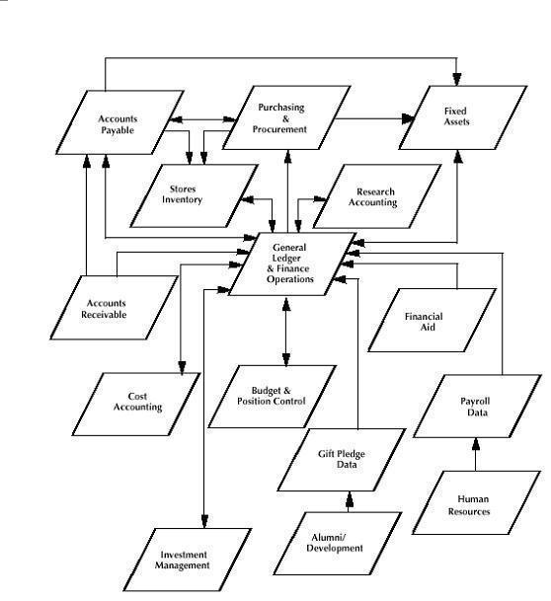

Fiscal Year
The college’s fiscal year is from June 1 – May 31; this 12-month period is used for budgeting, accounting, and financial reporting purposes. Months of the fiscal year are denoted as follows:

June: 1 | July: 2 | August: 3 | September: 4 | October: 5 | November: 6
December: 7 | January: 8 | February: 9 | March: 10 | April: 11 | May: 12

Certain activities, such as employee benefit plans as well as tax reporting (individual employee, independent contractor) are performed on a calendar-year basis as prescribed by the plan documents and/or governing body, respectively.

Accrual Basis of Accounting
The college has adopted the accrual basis of accounting (vs. the cash basis). As such:
- Revenue is recognized when earned, regardless of when cash is received.
  - If revenue is recognized prior to receipt of cash, it is considered a receivable (an asset). Example: pledges receivable.
  - If cash is received prior to the period earned, the transaction considered deferred revenue (a liability). Example: student tuition revenue received for a future academic period.
- Expenses are recorded when incurred regardless of date of payment.
  - If the college outlays cash prior to the expense date, the transaction is considered a prepaid expense (an asset). Example: a multi-year contract paid upfront or payment for an event that occurs in a future fiscal year.
  - If the college has incurred the expense but not yet outlaid cash, the transaction is considered an accrued liability. Example: accrued payroll (work has been completed through the end of the month but payroll will occur in the proceeding month).

Deferred, prepaid and accrual transactions may be recorded on an annual or interim basis, depending on the type of transaction. The college has elected to record many of these types of transactions annually in conjunction with its year-end close. At the end of the fiscal year, the college assesses the timing of delivery of goods and/or performance of services to determine the appropriate accounting treatment for the activities; goods must be received, and services must be performed in the current fiscal year to be expensed in the same. A threshold of $1,000 has been established for prepaid expenses.

Types of Accounts
Financial transactions are accounted for in five major account types: assets, liabilities, equity, revenues, and expenses.

Account Type | Informal Description
Asset | Things of value owned by the organization.
Liability | Amounts owed to external parties.
Equity (also called net worth or net assets) | The difference between assets and liabilities, theoretically the amount that would be received upon liquidation of the business.
Revenue | Amounts earned from external sources.
Expense | Amounts paid to external sources for goods or services.

Financial transactions are recorded as either debits or credits to accounts thereby increasing or decreasing account balances.

Account Type | Debit | Credit | Normal Account Balance | Example Debit | Example Credit
Asset | Increase | Decrease | Debit | 100 + | 100 -
Liability | Decrease | Increase | Credit | 100 - | 100 +
Equity | Decrease | Increase | Credit | 100 - | 100 +
Revenue | Decrease | Increase | Credit | 100 - | 100 +
Expense | Increase | Decrease | Debit | 100 + | 100 -

Financial Statements
On a monthly basis, the college prepares several financial statements. Major financial statements are described below:

Statement of Financial Position (Balance Sheet)
The statement of financial position provides information about the college’s assets, liabilities, and net assets as of a specific period of time. The statement of financial position helps assess the following:
- The college’s assets (what it owns), including assets availability for liquidity to meet short-term obligations.
- The college’s liabilities (what it owes), including it’s short- and long-term debt profile.

Statement of Activities (Income Statement)
The statement of activities provides information on the financial performance of the college over a specific time period. The statement of activities helps assess the following:
- Revenue recognized during a specific time period.
- Expenses incurred during a specific time period.

Statement of Cash Flows
The statement of cash flows provides information about cash receipts and cash payments of the college during the period. The Statement of Cash Flows helps assess the following:
- The college’s ability to generate positive future net cash flows.
- The college’s ability to meet obligations and its needs for external financing.
- The College’s differences between net income and associated cash receipts and payments.
- The effects of the college’s financial position of cash and noncash investing and financing transactions during the period.

Transactions that occur at the individual, departmental, and divisional level compose the financial statements. As such, all financial transactions must comply with accounting standards, rules, and regulations and/or any other applicable rules or regulations.

COLLEGE ADMINISTRATIVE SYSTEMS

Access to Financial Information

Workday Financials Security Model
Workday Finance is the college’s system of record for financial transactions and spend-related business processes. Workday Finance uses a role-based security model to secure financial information. Positions at the college are assigned roles based on their responsibilities and the area(s) of college operations they support. This role-based model ensures the following:
- When a worker is hired or transfers into a position at the college, they automatically receive access to the financial information required for that position.
- When workers separate from or leave a position at the college, they automatically lose access to the financial information granted by the position they once held.
- Consistency of access controlled and derived by the position rather than individual people.
- Granular roles allow more flexibility in which financial tasks a role can perform and which financial information a position can see.
The primary roles governing the visibility of financial information are:
Role | Description
Cost Center Manager | A role that can view financial transactions and approve spending transactions for a Cost Center.
Cost center hierarchy manager | A role that can view financial transactions and approve spending transactions for a group of related Cost Centers (e.g., the “Dining Services” Cost Center Hierarchy Manager has decision-making authority over and visibility to “Ed’s”, “Phil’s Dining”, “Ruth’s Marketplace”, etc., which are all subordinates of “Dining Services”).
Cost Center Hierarchy Manager (Division VP) | A role that can view financial transactions and approve spending transactions for a group of related Cost Center Hierarchy Levels (e.g., the “Business and Finance” Cost Center Hierarchy Manager (Division VP) has decision-making authority over “Human Resources”, “Financial Services”, “Facilities”, etc., which are all subordinates of “Business and Finance”).
Cost center financial analyst | A role that can view financial transactions for one or more Cost Centers or Cost Center Hierarchies. This role is primarily an administrative support & reporting role that does not have decision-making authority.
Gift manager | A role that can view financial transactions and approve spending transactions for a Gift.
Gift Financial Analyst | A role that can view financial transactions for one or more Gifts or Gift Hierarchies. This role is primarily an administrative support & reporting role that does not have decision-making authority.
GRANT manager | A role that can view financial transactions and approve spending transactions for a Grant.
GRANT Financial Analyst | A role that can view financial transactions for one or more Grants or Grant Hierarchies. This role is primarily an administrative support & reporting role that does not have decision-making authority.
PROGRAM manager | A role that can view financial transactions and approve spending transactions for a Program.
PROGRAM Financial Analyst | A role that can view financial transactions for one or more Programs or Program Hierarchies. This role is primarily an administrative support & reporting role that does not have decision-making authority.
FUND manager | A role that can view financial transactions and approve spending transactions for a Fund.
FUND Financial Analyst | A role that can view financial transactions for one or more Funds or Fund Hierarchies. This role is primarily an administrative support & reporting role that does not have decision-making authority.

In addition to the above roles, users who meet the following criteria are granted access to “company-level” financial information:
- Holds a position on the Accounting Services or Financial Planning & Analysis teams.
- Is the President of the college.
- Is the Vice President for Finance & Finance/CFO or Assistant Vice President for Financial Services.
- Holds a role responsible for the administration and/or technical support of Workday Finance.
- Holds a role responsible for developing “company-level” financial reports and dashboards.

Workday Finance Role Assignment Change Process
The “Finance Organization Administrator” (Accounting Services) role has the primary responsibility of making role assignment changes in Workday Financials. “Security Administrator” (Information Technology Services) can change role assignments.
Users contact Accounting Services to request a role assignment change. The “Finance Organization Administrator” evaluates the request for appropriateness based on the user’s position. If appropriate, the “Finance Organization Administrator” submits the role assignment change in Workday.
Role assignment changes are initiated in Workday using the “Assign Roles – Add/Remove” related action off the Worker or Position. A comment is required explaining the reason for each change. An audit record in Workday is automatically created including the initiating user, date/time stamp, comments, and specifics on what was changed.

Workday Adaptive Planning Security Model
Workday Adaptive Planning is the college’s budget and financial forecasting system. It consumes financial data from Workday Finance. Workday Adaptive Planning uses a combination of role-based and access rule-based security models to secure financial information and grant the appropriate level of access to budget data.
The visibility to financial information in Adaptive Planning mirrors the role assignments in Workday Finance (e.g., if a user is assigned as a “Cost Center Manager” or “Cost Center Financial Analyst” to the “CC310000 Accounting Services” Cost Center in Workday Finance, they will receive corresponding access in Workday Adaptive Planning through a combination of “Owned Levels” and “Access Rules”. This access rule-based model ensures the following:
The appropriate level of budget access (e.g., view-only or edit) is paired with corresponding visibility to historical financial transactions for combinations of elements within Workday’s Foundation Data Model (FDM). For example, the “Budget Developer” responsible for entering budget data for the Cost Center “CC310000 Accounting Services” is able to “edit” Budget data for this Cost Center and view historical financial transactions to analyze actual activity against current or past budgets.
The primary roles (permission sets) governing the budget development and financial reporting within Adaptive Planning are:
Role | Description
Budget owner | A role that can view financial transactions and edit or approve budgets for one or more Cost Centers or Cost Center Hierarchy levels.
BUDGET OWNER – SALARY | A role that can view financial transactions and edit or approve budgets for one or more Cost Centers or Cost Center Hierarchy levels. This role can view budgets and salary for positions.
BUDGET DEVELOPER | A role that can view financial transactions and edit budgets for one or more Cost Centers or Cost Center Hierarchy levels.
budget developer – salary | A role that can view financial transactions and edit budgets for one or more Cost Centers or Cost Center Hierarchy levels. The role can review budgets and salary for positions.
VIEW ONLY | A role that can view financial transactions for one or more Cost Centers or Cost Center Hierarchy levels.

The role (permission set) in Adaptive Planning is determined by the primary role assignment in Workday Financials (see above) based on the following matrix:
Workday Financials Role | Workday Adaptive Planning Permission Set
Cost Center Manager | Budget Owner
Cost Center Hierarchy Manager | Budget Owner
Cost Center Hierarchy Manager (Division VP) | Budget Owner
Cost Center Financial Analyst | View Only
Gift Manager | View Only
Gift Financial Analyst | View Only
Grant Manager | View Only
Grant Financial Analyst | View Only
Program Manager | View Only
Program Financial Analyst | View Only
Fund manager | View Only
Fund Financial Analyst | View Only

A “Cost Center Financial Analyst”, by default, begins with the “View Only” permission set. The users that hold these roles sometimes also assist in the budget development process for a “Cost Center” or “Cost Center Hierarchy” in support of the “Budget Owner”. If they are assisting in the budget development process, then a request can be made to the “Director of Financial Planning & Analysis”. If approved by the “Director of Financial Planning & Analysis”, then their permission set is changed to “Budget Developer”.

Visibility to Salary Data in Adaptive Planning
A limited number of users are allowed to view salary data. A user is granted access to view salary data if they meet one or more of the following criteria:
- Holds a position on the Financial Planning & Analysis team.
- Is the Vice President for Business & Finance/CFO or Assistant Vice President for Financial Services.
- Holds a role responsible for the administration and/or technical support of Workday Adaptive Planning.
- Holds a role responsible for developing “company-level” financial reports and dashboards.

Visibility to Aggregated Personnel Costs in Adaptive Planning
A user is granted visibility to aggregated personnel costs if they meet one or more of the following criteria:
- Holds a role assignment of “Cost Center Manager” or “Cost Center Hierarchy Manager” in Workday Finance.
- Holds a position on the Accounting Services or Financial Planning & Analysis teams.
- Is a member of the President’s Cabinet.
- Is the Vice President for Business & Finance/CFO or Assistant Vice President for Financial Services.
- Holds a role responsible for the administration and/or technical support of Workday Adaptive Planning.
- Holds a role responsible for developing “company-level” financial reports and dashboards.
- User holding the role of “Cost Center Financial Analyst” that was granted approval to view this data for one or more “Cost Centers” or “Cost Center Hierarchy” levels to which they are assigned.
A “Cost Center Financial Analyst”, by default, is only able to view aggregated personnel costs for the Ledger Account “600000: Salaries and Wages” and Spend Categories “Student Wages” and “Federal Work Study”. An exception to this rule can be approved by the Director of Financial Planning & Analysis or the Assistant Vice President of Financial Services.

Access to Workday Adaptive Planning
A user is granted access to Workday Adaptive Planning if they meet one or more of the following criteria:
- Holds a role assignment in Workday Finance that grants the ability to approve spend transactions and/or view financial transactions for all or part of the FDM.
- Holds a position on the Accounting Services or Financial Planning & Analysis teams.
- Is a member of the President’s Cabinet.
- Is the Vice President for Business & Finance/CFO or Assistant Vice President for Financial Services.
- Holds a role responsible for the administration and/or technical support of Workday Adaptive Planning.
- Holds a role responsible for developing “company-level” financial reports and dashboards.

Workday Foundation Data Model - FDM
The FDM is a multi-dimensional data structure that is the framework for financial transactions and reporting within Workday. The FDM is composed of “driver” or “related” worktags; worktags represent individual dimensions. A “driver” worktag is the “primary” worktag that drives the transaction and must be entered by the end user or administrator. “Related” worktags will default and automatically populate based upon the selected driver worktag.

The following table briefly describes each worktag.

 | Worktag | Definition | Structure
 | Company | Organizations that represent the internal business entities to which transactions are posted and considered the level at which you hold a balance set of books. | SNC
 | Fund | Grouping of activities that have a balanced set of books that are separated into fund types that are characterized by restrictions. | FDXX
 | Cost Center | An identifier for financial responsibility and oversight of a managed and budgeted entity. Represents a department or unit of budgetary responsibility within the institution. Cost centers are used to hold financial transactions, budgets as well as workers. This is both a driver and a related worktag. | CCXXXXXX
 | Program | Identifies general operational activity not funded by Gifts/Endowments. (Capital Projects, Strategic Plan) This is a driver worktag. | PGXXXXXX
 | Gift | Used for non-grant external funding sources such as endowments and spendable gifts. This is a driver worktag. | GFXXXXXX
 | Grant | Used for specific funding sources provided by an outside sponsor (e.g. federal, state, local) associated with an award and with detailed reporting requirements. This is a driver worktag. | GRXXXXXX
 | Ledger Account | Identifies the specific type of transaction within the accounting categories of Asset, Liability, Equity, Revenue and Expense. Ledger accounts are summarized into hierarchies for financial reporting. A ledger account is associated with each revenue and spend category selected in a transaction. | 6 digit numeric
 | Revenue Category | Classifies types of revenue collected. (Other Revenue-Taxable) | Alpha
 | Spend Category | Identifies the type of good/service being purchased. (Supplies) | Alpha
 | NACUBO Function | Classifies expenses according to the purpose for which costs are incurred to create a standard reporting structure for Financial Statements. (Instruction, Institutional Support, etc.) This is a related worktag. | Alpha
 | Functional Expense | Classifies expenses according to their functional classification. (Programs, Management & General, etc.) This is a related worktag. | Alpha
 | Location | An optional code used to associate a physical location with a financial transaction. Primarily used to track fixed assets but also used for other situations such as segregating data by individual residence halls. | Alpha

Financial transactions to expense ledger accounts (accounts starting with a 6, 7, or 8) require a spend category. Financial transactions to revenue ledger accounts (accounts starting with a 5) require a revenue category.

Workday Custom Validations
Custom validations can be created to trigger a transaction validation and prevent errors on financial transactions. Custom validations vary by transaction type. Custom validations do the following:
- Alert transaction approvers to conditions that need more careful review.
- Display warning or error messages when workers create a transaction that meets the conditions for the validations.
- Prevent workers from submitting invalid transactions until they resolve an error.

The following are examples of custom validations that exist on financial transaction processing.
- Attachment is required.
- Revenue category is required on revenue accounts.
- Expense category is required on expense accounts.
- Memo is required.
- Contains inactive worktags.
- Driver worktag is required.
- Receipt required for items >$25.

Basic Workday Financial Reports
Workday is delivered with a standard set of financial reports. The various reports allow users to obtain data in varying levels of detail based on selection parameters (key values). Common end-user forms and reports are listed below:

- Trial Balance
- Ledger Account Activity Summary
- Ledger Account Activity Summary by Source
- CR FIN Ledger Account Journal Lines by Period
- CR Supplier Invoice Line Reconciliation
- Ledger Detail

Trial Balance
The trial balance displays ledger account balances for selected parameters. The report lists ledger account, up to two additional worktags selected in parameters, beginning balance, total debit amount for reporting period, total credit amount for reporting period, and ending balance for reporting period.

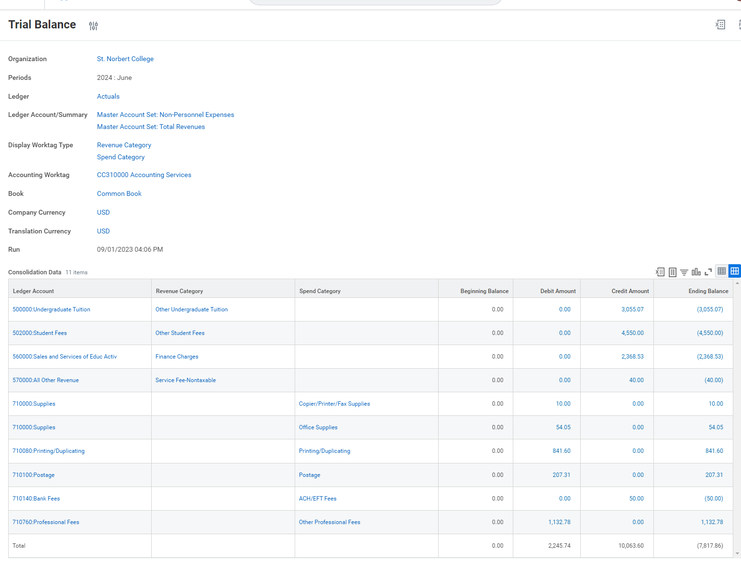

Ledger Account Activity Summary
This report displays each ledger account, based on prompts, and its debit, credit, and net amounts. Further, the end user can drill into the net amount to see journal entry details.

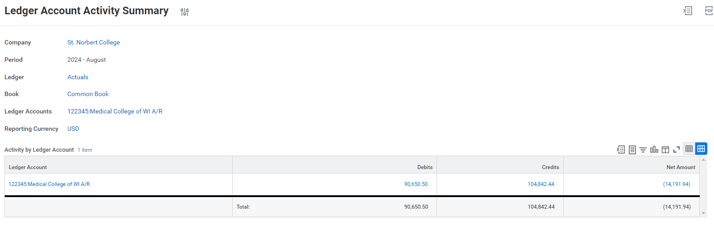

Ledger Account Activity Summary By Source
This report displays each ledger account, based on parameters, and its journal source, debit, credit, and net amounts. Further, the end user can drill into the net amount to see journal entry details.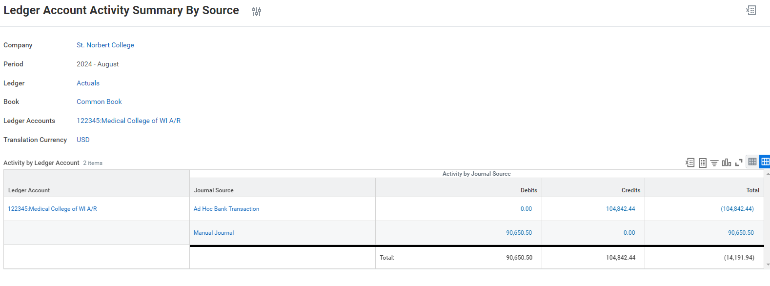
CR FIN Ledger Account Journal Lines by Period
This report groups journal entries by account, year, period, and accounting date.

CR AP Supplier Invoice Line Reconciliation
This report displays supplier invoice detail along with Cost Center for selected Supplier.

Ledger Detail
This report permits the end user to view a summary by period or the details of a ledger account. It enables the end user to report on the details in the ledger. The summary provides, by period, a beginning balance, activity, and ending balance. It also provides a snapshot of trending over periods.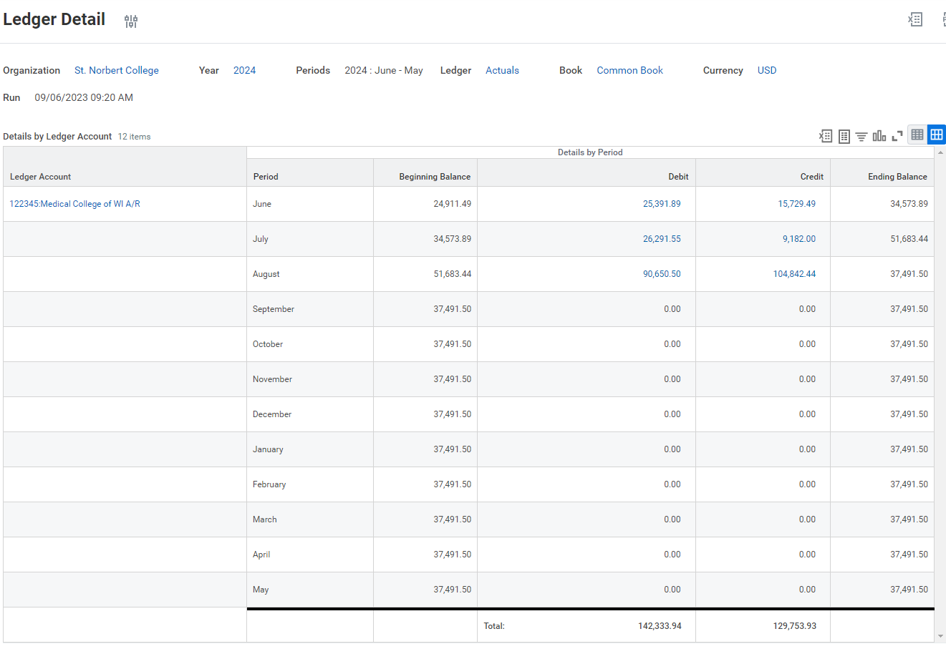

Adaptive Planning

Workday Adaptive Planning is the primary source of budget-related financial reporting. Budget managers primarily use three reports:

- Div Report - Cost Center by Fund
- Detail Expense by Fund
- Budget Status - Cost Center

Div Report - Cost Center by Fund
This report permits a budget manager to enter a Cost Center or Cost Center Hierarchy Level and view a summarized view of both budget and actuals by General Ledger Account. The user can also narrow this report down to individual funds by gift, endowment, or operating in total.
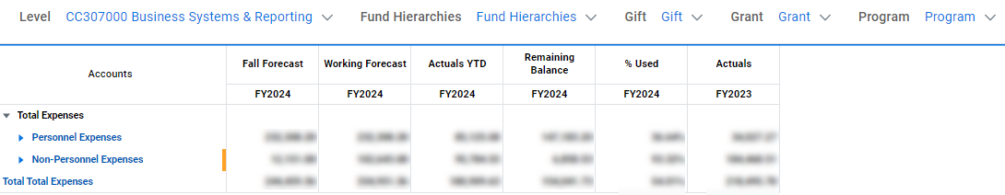

Detail Expense by Fund
This report permits a budget manager to enter a Cost Center or Cost Center Hierarchy Level and view summarized view of both budget and actuals by Spend Category and General Ledger Account. It offers a deeper level of detail than the “Div Report - Cost Center by Fund” report and is useful when trying to understand activity within a General Ledger Account. This report will split out the different funds within the cost center, which offers visibility into the funds within a specific area. It will split out each gift and endowed fund and then operating (no gift).
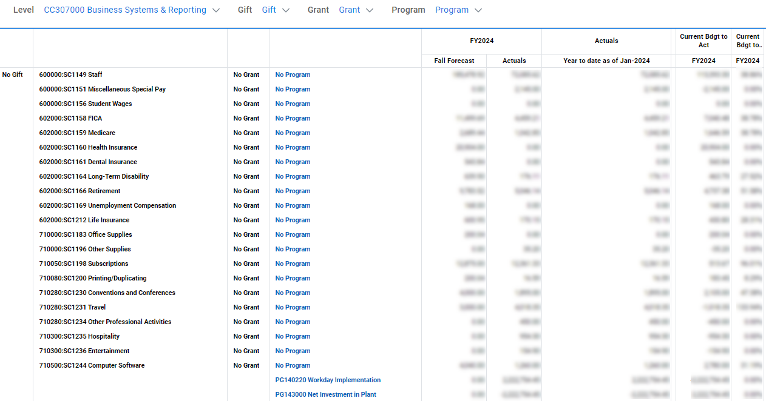

Budget Status - Cost Center
This report permits a budget manager to enter a Cost Center or Cost Center Hierarchy Level and view different level of summarization (Fund, Program, Gift, Grant or Endowment) and then view Ledger Account detail for each of them. It supports “Drill-Through” functionality that allows the budget manager to click on an “actual” and drill-to Workday Finance to view the Journal Entries that make up the total.

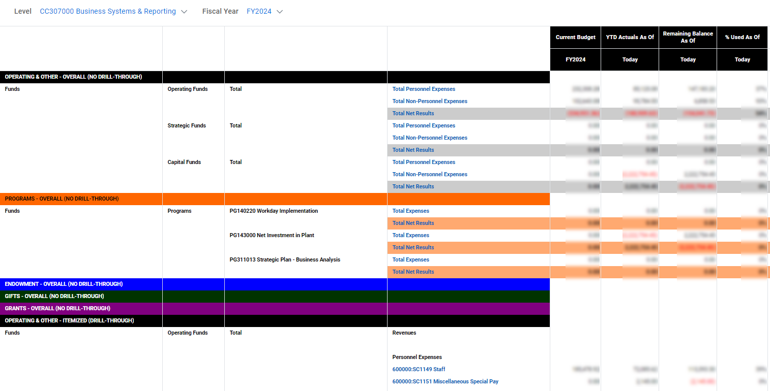

COLLEGE ACCOUNTING MANAGEMENT

Requesting Transfers, Adjustments and Corrections
In the normal course of business, it may be necessary for transfers or corrections of prior transactions. Further, it may be necessary to perform a budget entry.

The criteria for requesting a journal entry are described below:

A Journal Entry is used to adjust actual revenue recognized or expenses incurred. Journal entries are also used to adjust balance sheet accounts including assets, liabilities, and fund balances. A common use of a journal entry is to make coding adjustments where, for example, a particular gift, grant, program, cost center, spend category, revenue category or account incurred expenses that need to be recorded in a different gift, grant, program, cost center, spend category, revenue category or account.

The recommended procedure for submitting a journal entry is to use a Journal Entry Request Form available online from the Accounting Services Department webpage and then emailing the form to Accounting Services who will record the journal entry. The form contains a sample journal entry to help guide end users. Use of the form accomplishes the following:
- Provides a standardized structure for collecting data elements as required by Workday Finance.
- Provides the Accounting Services team the most efficient mechanism for recording the transaction in Workday; the Accounting Services team can copy/paste the data into Workday.
- The excel file serves as an internal control for certain validation checks which is used to minimize errors and/or omissions. The online form includes a sample journal entry.

Understanding and Managing Agency Funds
Agency funds are held in a custodial capacity by the college for faculty, staff, student organizations or others closely aligned with the college’s mission. Agency funds are held in trust for others so do not involve measurement of college revenues and expenses. Accordingly, financial activity, both inflows and outflows, is usually recorded in a single assigned Workday program. These programs are reflected as liabilities on the Statement of Financial Position. A running balance like a checking account is maintained.

An example of a college agency activity is a student organization. Student-led organizations might recognize revenues and incur expenses but are not directly owned by the college. Financial transactions are recorded within the college’s financial system on behalf of the student organization with the college acting as an agent. A credit balance in the specific student organization’s Workday program represents funds held in trust by the college while a debit balance represents amounts owed to the college.

Any transfers, adjustments or corrections involving agency accounts must be processed as journal entries.

Understanding Endowments
An endowment is a financial arrangement that is typically intended to provide a long-term source of funding to the college. The college’s endowments are subject to the Wisconsin Uniform Prudent Management of Institutional Funds Act (WUPMIFA) in terms of requiring the preservation of the fair value of the original gifts as of the gift date of the donor-restricted endowment funds, absent explicit donor stipulations to the contrary. Additional guidelines are outlined in the footnotes of the college’s annual financial audit report.

It is common for donors to direct endowed funds for the following specific purposes: student scholarships, faculty chairs, academic programs, general operations, or other specific programs. The college frequently uses the terms “scholarship endowment” and “program endowment” to refer to an endowment’s purpose as relating to either student scholarships or support of other college purposes.

There are two primary categories of endowments: with donor restrictions and without donor restrictions.

- Endowments classified as “with donor restrictions” are funds where the principal or corpus is held in perpetuity and invested. Only the return on investment may be used as a funding source.
- Endowments classified as “without donor restriction” are funds from which either the investment return or some portion of the principal may be used as needed.

When donors agree to fund an endowment, the donor and the college enter into a legal agreement that identifies any special conditions or donor stipulations. The college has a variety of arrangements to accommodate specific donor requests and to broaden the pool of potential donors. In recent years, there has been an effort to streamline the arrangements and to provide flexibility in the future uses of funds.

Endowment Asset Pooling
Endowment assets are invested in either a pooled or non-pooled method. Pooled assets are managed like a mutual fund whereby individual endowments are accounted for separately, yet funds are commingled for investing and accounting efficiencies. Non-pooled assets are invested according to donor stipulations which may involve specific types of financial instruments. Each participating pooled endowment is assigned a certain number of units in the pool at the time the endowment is established. The process of calculating units in the pool per endowment is called unitization. The number of units is adjusted monthly to include endowment additions.

Unitization Example based on a single endowment
Pool Market Value | 10,000,000
Units | 100,000
Market Value per Unit (pool market value / units) | 100

If a new $15,000 endowment were added to the pool the number of additional units would be 150 ($15,000 endowment / $100 market value per unit).

Unitization Example with added endowment
Pool Market Value | 10,015,000
Units | 100,150
Market Value per Unit (pool market value / units) | 100

The market value of the endowment is the original donation plus additions plus investment earnings and appreciation, less distributions, and less fees. The monthly market value of the overall pool is determined by summing the value of all investment vehicles included in the pool. New pooled unit valuations are made by dividing the total market value by the number of units.

Example Market value and pooled unit valuations
 | Units | Price Per Share | Market Value
Starting Pool Market Value |  |  | 10,000,000
Units | 100,000
Market Value per Unit (pool market value / units) |  | 100
Gifts | 150 |  | 15,000
Add: Net Income (interest plus dividends minus fees) |  |  | 70,000
Add: Earnings and appreciation (realized and unrealized gains and losses) |  |  | 200,000
Less: Distributions | -500 |  | -50,000
Ending Pool Market Value |  |  | 10,235,000
Ending Market Value per Unit and Shares | 99,650 | 103

Endowment Spending Policy
When a donor donates to establish an endowment, the endowment gift is created. Each endowment gift will have three funds. The restricted fund represents the principal (donations), the temporarily restricted fund represents the investment activities, and the unrestricted fund represents budgeted distributions and actual expenditures in accordance with the endowment agreement. The budgeted distribution or amount available to spend is based on the college’s endowment spending policy.

The board of trustees determines the annual spending rate for the majority of the endowed funds. The St. Norbert Abbey determines the spending rate of The Premonstratensian Fathers (TPF) funds. The respective spending rates inform the upcoming fiscal year’s allocation of spendable funds, or budget.

Spending rates are typically determined from a formula based on historical market values which reduces volatility in payout rates. For example, the college uses a calculation as of June 30 of the preceding budget year based upon the previous XX quarters. The St. Norbert Abbey uses a calculation as of December 31 based upon the previous XX quarters.

As an example, let’s say a spending policy uses an average market value of 12 quarters which amounts to an average unit value of $75. Let’s also presume the institution has established a spending rate of 4.5% of the 12 quarter average market value. An endowment with 150 units would generate an annual spending amount of $506.25 (150 units x $75 (avg 12 qtr unit value) x 4.5%).

Managing Endowment Activity
Each college endowment is assigned a unique Workday gift code to enable tracking of endowment activity; there are several hundred endowment gifts in the Workday system. Budget managers must use the endowment’s spendable fund (gift) code to post expenses against the spendable gift in Workday.

Budgeted spending allocations are assigned to account 710990-Other Expenses with the spend category (Endowment Spending or SC1306). Depending upon the intent of endowed fund, budget and subsequently, actual expenses, may be allocated to salaries, fringe benefits, travel, supplies, etc.

Below is an example of financial data relating to an endowment with a budget of $5,000 in spendable funds.

Organization: CC123456 – College Operations
Fund: GF129999 – Endowment 1
Account | Account Title | Budget | Year-to-date (actuals) | Available Balance (Variance)
Expense
700000 | Supplies |  | 1,500 | -1,500
710100 | Postage |  | 600 | -600
710280 | Travel |  | 0 | 0
710990 | Endowment Spending | 5,000 |  | 5,000
Net Total |  | 5,000 | 2,100 | 2,900

For expenses to be correctly charged to the endowment, the fund code of GF129999 and org code of CC123456 must be used along with the appropriate account for the category of expense (travel, supplies, postage . . . etc.). In the example above, $5,000 was the designated spendable amount and $2,100 has been expensed to date. For budget management purposes, it is important that the net total year-to-date does not exceed the net total budget.

Fiscal Year-End
The close of each fiscal year involves preparation of financial statements in accordance with generally accepted accounting principles. Year-end financial statements are audited by independent external auditors who issue an opinion as to their fairness and conformity with accounting principles. The desired result of an audit is an unqualified audit opinion.

The audit includes an examination of evidence supporting amounts and disclosures in the financial statements as well as assessing accounting principles used and internal controls. External auditors conduct the majority of fieldwork onsite following the May 31 fiscal year end.

To close the year and prepare financial statements in a timely manner, budget managers are expected to expedite any year-end transactions, invoice requests, journal entries, expense reports, and/or disbursements within a few days after May 31. The Accounting Services team sends out notifications identifying such expectations and deadlines. Transactions and/or requests received after the deadline will be posted to the subsequent fiscal year.

Examples of such transactions that require budget managers’ attention from a deadline perspective include but are not limited to:
- Various internal year-end accounting adjustments, including accruals and deferrals.
- Payment of suppliers and payment of staff travel reimbursements.
  - Expenses are charged to the fiscal year in which goods are received and/or services are performed regardless of when the actual cash disbursement is made.
  - For example, the college must take delivery of the goods and accept performance of the service(s) within the current fiscal year for the expense to be incurred in the same.
  - The facts and circumstances of the transaction and correct accounting treatment take precedence over budget availability.
- Transactions that relate to more than one fiscal year, such as service agreements, annual or multi-year contracts or license agreements.
  - For agreements $1,000 and greater, the expense will be incurred over the period of the agreement. The Accounting Services team will evaluate these transactions on a case-by-case basis in the event a special circumstance exists.

CASH MANAGEMENT

Deposit of Receipts
To ensure appropriate accounting and safeguarding of cash, the college has established the following internal controls:

Policy: Deposit of Receipts

The college requires that all receipts (cash, checks, money orders or other financial instruments) be hand-delivered to Student Account Services daily during business days/hours. For cash collected outside of business hours, deposits must be stored in a locked departmental safe or deposited to the Student Account Services lock box. This policy helps the College optimize cash flow, maximize short-term investment income, safeguard assets, and reduce administrative burdens associated with stale-dated checks and cancelled credit cards.

For audit, documentation, and accountability purposes, it is required that any physical transfer of funds to Student Account Services is accompanied by a completed Deposit Transmittal Form indicating the following:
- Transmittal date.
- Transmitting department.
- Name and signature of person responsible for deposit.
- Itemization of cash, coin, checks, etc., including the total transmittal amount.
- Source and/or purpose of funds.
- Workday coding (ledger account, cost center and spend category) to which deposit is to be applied.

All deposits should be hand-delivered to a Student Account Services team member who will date stamp and initial the deposit. Any applicable receipts will be attached. Deposits should not be routed via internal mail.

Deposit transmittal forms can be accessed from the forms link on the Accounting Services Department web page.

Petty Cash
Petty cash funds have been established at various locations on campus for the purpose of reimbursing individuals for incidental business related expenses. The recommended maximum reimbursement amount is $30. For administrative efficiency, petty cash is the preferred method of reimbursement of expenses under $10. Each petty cash fund is assigned to a custodian who has responsibility for appropriate administration and safeguarding of the fund.

Petty cash funds are to be maintained on an imprest basis meaning that the sum of cash on hand plus receipts or other documentation of disbursements must equal the total authorized fund amount. Written documentation including original receipts should be maintained for each petty cash payout. At a minimum the documentation should include the name of the individual receiving cash, the business purpose and/or itemized list of purchases for which petty cash is being requested, amount, date and Workday FDM coding for charging the expense. For audit purposes, original receipts or a written explanation of why there is not an original receipt should be maintained for each payout.

Custodians are responsible for restricting access and safeguarding funds. For internal control purposes, accounting services department staff may make periodic unannounced audits of petty cash to verify balances and supporting documentation.

Establishment of petty cash funds or changes in amounts must be approved by the Assistant VP for Financial Services. To ensure appropriate control and accountability, the Assistant VP for Financial Services should be notified whenever a change of custodian occurs.

Petty cash funds have been established at the following campus locations:
- Admissions
- Sensenbrenner-lower
- Boyle Hall 333
- Facilities Service Center 103
- Mail Center
- Main Hall 107
- Mulva Library 111

Change Funds
Change funds are essentially cash advances from general college funds to custodial departments for the purpose of making change. The amount of a change fund remains constant and does not require periodic reimbursement. Change funds may not be used to make petty cash disbursements or other cash advances. Custodians are responsible for restricting access and safeguarding funds. For internal control purposes, accounting services department staff may make periodic unannounced counts of change funds to ensure proper accountability is being maintained.

Establishment of change funds or changes in amounts must be approved by the Assistant Vice President of Financial Services. To ensure appropriate control and accountability, the Assistant Vice President of Financial Services should be notified whenever a change of custodian occurs.

Change funds have been established in the following campus locations:
- Mulva Fitness Center
- Todd Wehr 128
- Cofrin 328
- PAC
- Kress Inn
- Mail Center
- Todd Wehr 124

PURCHASING AND CASH DISBURSEMENTS
The overarching goal of campus purchasing is to maximize the value of goods and services while providing honest, ethical, and responsible stewardship of financial resources. Once purchases have been made, appropriate procedures must be followed to verify the receipt of goods or services, make timely payment to suppliers, and establish appropriate documentation for audit and accountability purposes.
There are several available methods for sourcing and paying for college-related expenses, including:
- Expense reports
  - Expense reimbursements for travel and small expenses paid out of pocket.
  - College-issued credit cards used for travel and small expenses.
- Supplier invoices
  - Supplier invoices are intended to be used for verbal orders of goods and services to be directly billed to the college for items less than $5,000. Some exceptions and use cases exist for supplier invoices that involve large amounts, including but not limited to items such as utilities, insurance, property taxes, and pass-through/payroll transactions.
- Requisitions and purchase orders
  - Non-catalog requisitions are intended to support the pre-approval of goods, services, and contracts $5,000 and greater.
  - Punchout requisitions are intended to complement the colleges purchasing strategy. The college has selected key suppliers to integrate directly with Workday Finance. A punchout drives end users to supplier websites; requires a pre-approval for all items, regardless of dollar value; and creates an automated bidirectional purchase order and invoice process.
- Per diem (athletics)
  - To comply with NCAA guidelines, the college has implemented a third party gateway for disseminating per diem to support student-athlete meal needs.
- Cash advances
  - The college does not support the use of cash advances.

Decentralized Purchasing and Receiving
In the absence of a centralized purchasing office, a decentralized approach to purchasing has been employed. Within certain spend parameters and approval guidelines, budget managers have been given autonomy to direct purchasing and receipting activities within their own areas.

Contract Authority and Policy
SNC supports a contract environment based upon the understanding that centralized review and signing authority best supports the college’s endeavor to optimize suppliers; ensures contract terms and provisions are appropriate, consistent, and acceptable; and ensure that financial obligations and legal commitments are aligned with the college’s mission, budget and all applicable laws and regulations.
Key tenets of the contract policy include:
- A contract is defined as a written agreement between two (2) or more parties, one of which is the college, that obligates the college to provide payment, services, goods, or use of college property, facilities, equipment, or other resources to a third party. A contract may or may not involve the exchange of money to settle an obligation.
- Only certain positions, as defined by the policy, can commit the institution to a contractual agreement. No other positions have the authority to execute a contract.
- Budget must be available to support the contract.
- The contract stipulates levels of spend required for bids and requests for proposals.
- All contracts are required to be stored in Business & Finance.

Expense Card Policy
Employees with a demonstrated business need may be eligible to receive a college-issued expense card if they are engaged in frequent business-related travel and/or make routine small dollar-value purchases for which a purchase order or direct supplier invoice may not be feasible.
The divisional vice president as well as the Assistant Vice President for Financial Services must approve all college-issued expense cards as well as any limit increases.
Approved and unapproved uses of the expense card are outlined within the policy. Inappropriate expenses include but are not limited to: capital expenditures; software/licenses; fuel for personal vehicles (the college reimburses mileage at the IRS-approved rate); utilities; birthday/individual celebrations not outlined within the college’s human resources policies; personal purchases; expenses that can billed directly to the college; and cash advances.
Expense cards are issued at an individual-level; standard card limits are $2500 for individual cardholders. Exceptions exist for seasonal travel, the President, and the President’s Cabinet. All exceptions are approved by the Assistant Vice President for Financial Services.
To help ensure timely and accurate financial recording, expense cards are required to be reconciled within 15 days of the transaction date.

Food, Alcohol, Entertainment, & Gift Policy

The college supports an environment that promotes the values of radical hospitality while being good financial stewards of the college’s resources.

Key tenets of the policy include:
- Modest refreshments at college-wide or divisional/departmental meetings may be permitted, depending upon the circumstances.
- Employees who purchase alcohol in conjunction with a college event must comply with all federal, state, and local regarding alcohol consumption.
- Transactions pertaining to travel, meals, and/or entertainment must be accompanied by an itemized receipt(s) as well as a list of attendees. For athletic team meals, a list of attendees is not required.
Interdepartmental Transactions
Interdepartmental transactions that occur within the college are documented via journal entry.

Accounts Payable Disbursements
The primary purpose of the Accounts Payable department is to pay the college’s non-payroll financial obligations in a timely and accurate manner as well as ensure the payments have appropriate documentation. Accounts Payable processes payments for suppliers, faculty, staff, and students.

The Accounts Payable office is responsible for ensuring that disbursements comply with internal and external rules and regulations. A supplier invoice is considered the standard required documentation to trigger a request for payment and thus, college expense. The requesting budget manager or department has the primary responsibility for entering the supplier invoice request into Workday, which is then routed for internal review and approval. A W-9 must be submitted for any new supplier to be included in the college’s supplier portfolio.

Payments are issued on a weekly payment cycle each Thursday. Payment requests (complete, accurate, and authorized) must be received in Accounts Payable’s Workday inbox by 4:00 p.m. on the previous Tuesday to be included in a Thursday payment cycle. Variations in the payment schedule may occur due to holidays or other special timing situations such as year-end cutoff deadlines.

Travel and Expense Reimbursements
Employees may be reimbursed for reasonable and necessary business expenses. In keeping with IRS accountable plan rules, proper documentation must be provided in support of expense reimbursements. The college’s travel and expense reimbursement policy is listed below:

General Policy
The college will reimburse employees for reasonable and necessary expenses incurred in conjunction with job related responsibilities.

Reimbursement requests are not to be submitted for items provided free of charge, not personally paid for by the requestor, reimbursed by another source, or which will be paid or reimbursed by another source. Any reimbursement which is received by the requestor from another source for items reimbursed by the college shall be returned to the college.
IRS Requirements
Reimbursement procedures must comply with IRS Accountable Plan rules for travel reimbursements to be considered non-taxable income to employees. The college does not have a per diem policy. Without proper documentation, reimbursements must be reported as income on an employee’s W-2 form. Accountable Plans must meet the following requirements:
- Reimbursements must be made for business-related expenses only.
- Requestors must provide written substantiation of expenses within a reasonable time. The college requires reimbursement requests to be made within 30 days of the associated expense.
- Employees must return any amounts in excess of properly substantiated expenses within a reasonable time after incurring expenses. The college requires return of excess amounts within 30 days of associated expenses

Meal Reimbursement Guidelines
Meal expenses, including gratuities, will be reimbursed at actual costs up to established maximums as listed below:

Breakfast: $10.00 | Lunch: $15.00 | Dinner: $30.00

In cities with populations exceeding 1 million the maximum dinner allowance is $50. Business meals are defined as meals taken with students or colleagues where specific college related business discussions take place or meals are due to college related travel. Exceptions to maximums may be allowed with the approval of the employee’s supervisor.

Gratuity
The College will reimburse routine and customer gratuities of up to 20% of the total bill for catering, meals, and other travel services.

Documentation Requirements
Reimbursement requests should be submitted via Workday’s expense module. Job aids for expense reports are available online or can be requested through Accounting Services. Requirements include but are not limited to:
- Original receipts must be included for any item exceeding $25.
- Lodging receipts must be itemized. Credit card receipts, statements or cancelled checks are not sufficient to satisfy itemization requirements.
- Reimbursement requests for entertainment or hospitality expenses must include a description of the business purpose and names/titles of those being entertained. Entertainment that involves a meal and/or drinks require a credit card receipt that itemizes the expenses by individual meal. The unspecified total receipt is not sufficient.
- If receipts cannot be provided (such as taxi or parking meter charges), or were misplaced, a completed Missing Receipt Form should be provided (receipts are only required for items over $25).

Approval/Authorization for Expense Transactions
The approval process for requisitions, expense reports, and supplier invoice requests is completed via an automated workflow in Workday. The expense report will be sent through the following approval workflow: Requestor’s Manager, Cost Center Manager, Program Manager (If applicable), Gift Manager (If applicable), ITS Manager (If applicable), >$5,000 Divisional Vice President, >$2,500 V.P. Business & Finance.
Approver: Approvers have primary responsibility for ensuring that transaction requests are submitted in accordance with college policies. This includes reviewing accompanying documentation for completeness. Missing, incomplete or inadequate documentation should be resolved with requestors prior to submission of expense report for payment. Further, the approver is responsible for ensuring the expense is a legitimate business expense and that the appropriate worktags have been selected to represent the transaction. Approval requirements are as follows:
- The Approver must have authorization to approve for the account(s) being charged.
- The Approver cannot be the requestor.
- The Approver should be the requestor’s direct supervisor.
- The Approver should not report to the requestor.

Non-allowable Expenses
Expenses submitted for supplier invoice request, expense report, or requisition should be reasonable, necessary and business related. The following list of non-allowable expenses is not intended to be all-inclusive:
- Expenses not related to college business.
- Travel costs of spouses or family members (unless spouses or family members are employees on official college business).
- Personal entertainment.
- Traffic citations, parking tickets and other fines.
- Kennel fees.
- Excess cost of circuitous or side trips for personal reasons.
- Childcare costs.
- Extra costs for additional person(s) in room.
- Lost/stolen cash or personal property.

Travel and Expense Reimbursement Policy Changes
Changes to the travel and expense reimbursement policy must be approved by the Vice President of Business and Finance.

COLLEGE BUDGETING

Budget Cycle
The college has a continuous budget cycle that includes developing, long-range planning, forecasting, maintaining and capital planning. The college strives to make continuous improvements to all processes.

Budget Development Process
Annually, the college’s Financial Planning & Analysis (FP&A) department works with each division to plan for the subsequent year’s annual operating budget. Additionally, the Director of Facilities coordinates the capital plan and budget.

The financial services team maintains the budgets and plan. The financial services team is also responsible for allocating spendable gift budgets throughout the year. Budget managers and divisional vice presidents are responsible for ensuring budget is not exceeded.

Forecasting & Long-Range Planning
Typically, twice per year, in conjunction with census date of each academic term, the college prepares a forecast (re-forecast) of the annual operating budget and plan.

Further, throughout the year, the college prepares a long-range plan, which is a walk-forward of the operating budget or forecast. The long-range plan helps the college plan in future years.

